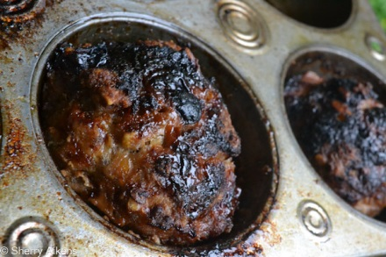
Gluten Free Meatloaf Muffins
- 1 lb of ground Turkey
- 1 lb of Ground pork
- 1 1/2 cups of corn chips
- 1 egg
- Barbeque sauce or catchup (for non phoroisis diet)
- Honey (for phoroisis diet)
- Onion soup mix or make your own below depended of gluten sensitivity
Make your own Onion Soup mix
- 3 tablespoon of dried minced onions or 1 small fresh onion min
- 2 tablespoons of soy sauce
- 1/4 teaspoon pepper
- 1/4 teaspoon salt
- 1/2 teaspoon of cumin

- Preheat oven to 375
- Spray muffin tin with non stick cooking spray or line with parchment
- Place corn chips in a bag and crush
- Mix Turkey, pork, egg, crushed corn chips and onion soup mixture in a large bowl Go head use your hands
- Place a handful of meat loosely formed in each muffin (do not pack the meat will not be as good trust me)
- With your finger poke a hole down the center of the muffin (this helps to avoid shrink)
- In hole fill with barbeque sauce or catchup (for thoes who can eat nightshades)
- OR Drizzle on top Honey for Restricted diet person (I would NOT fill the hole with honey too sweet)
- Cook for 30 minutes or until dark on top
- Remove allow the meat to rest for 10 minutes

http://www.superexhausted.com/2014/04/gluten-free-meatloaf-muffins/

